

LAB PROJECT REPORT

*MUHAMMAD SAQLAIN IQBAL*

HOTEL MANAGEMENT SYSTEM

Networking Project - Vic Modern Hotel

As a part of our networking project, we are required to design and implement the Vic Modern Hotel network. The hotel has three floors:

* The **first floor** hosts three departments:
* Reception, Store, and Logistics.
* The **second floor** has three departments:
* Finance, HR, and Sales/Marketing.
* The **third floor** has two departments:
* IT and Admin departments.

The following are considerations for the network design and implementation:

1. There should be three routers connecting each floor (all placed in the server room in the IT department).
2. All routers should be connected to each other using serial DCE cables.
3. The network between the routers should be:
   * 10.10.10.0/30
   * 10.10.10.4/30
   * 10.10.10.8/30
4. Each floor is expected to have one switch (placed in the respective floor).
5. Each floor is expected to have Wi-Fi networks connected to laptops and phones.
6. Each department is expected to have a printer.
7. Each department is expected to be in different VLANs, with the following details:

**First Floor:**

* Reception: VLAN 80, Network: 192.168.8.0/24
* Store: VLAN 70, Network: 192.168.7.0/24
* Logistics: VLAN 60, Network: 192.168.6.0/24

**Second Floor:**

* Finance: VLAN 50, Network: 192.168.5.0/24
* HR: VLAN 40, Network: 192.168.4.0/24
* Sales: VLAN 30, Network: 192.168.3.0/24

**Third Floor:**

* Admin: VLAN 20, Network: 192.168.2.0/24
* IT: VLAN 10, Network: 192.168.1.0/24

**Additional Requirements:**

1. Use OSPF as the routing protocol to advertise routes.
2. All devices in the network are expected to obtain IP addresses dynamically, with their respective router configured as the DHCP server.
3. All devices in the network are expected to communicate with each other.
4. Configure SSH on all the routers for remote login.
5. In the IT department, add a PC called "Test-PC" to port fa0/1 and use it to test remote login.
6. Configure port security on the IT department switch to allow only Test-PC to access port fa0/1 (use the sticky method to obtain the MAC address, with the violation mode set to shutdown).

STEPS:

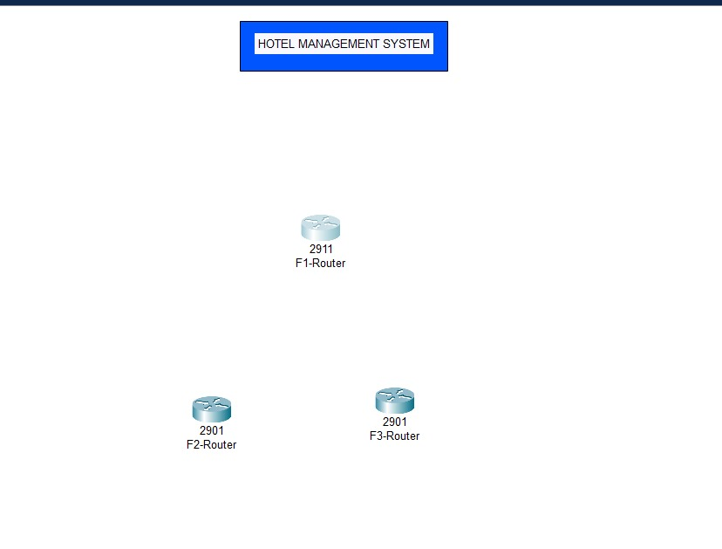**WE HAVE TOOK THREE ROUTERS:**

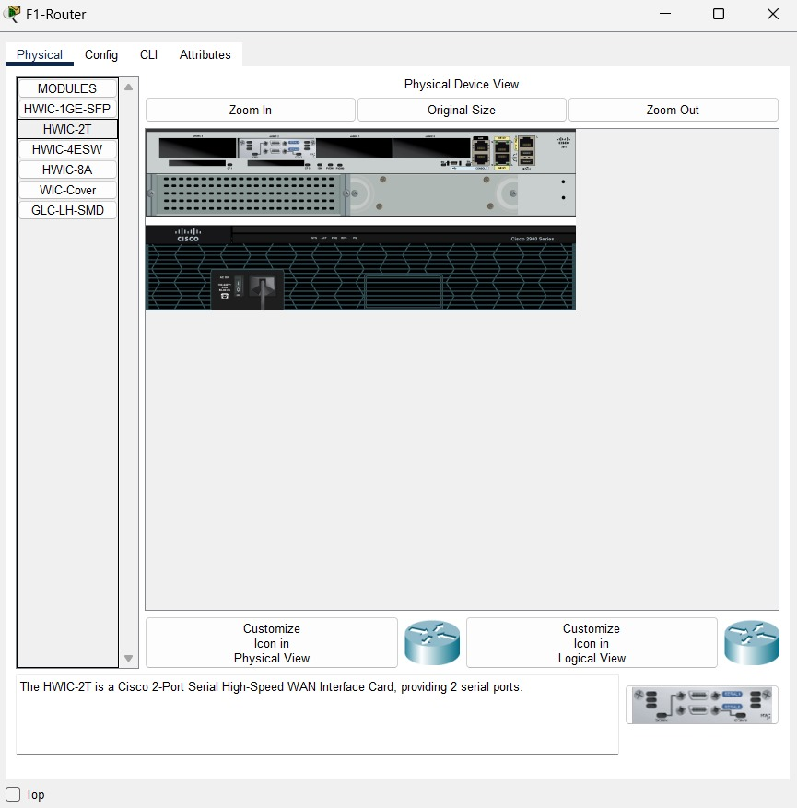**REPLACE F1-ROUTER PORT WITH HWIC-2T MODULE:**

**REPLACE F3-ROUTER PORT WITH HWIC-2T MODULE:**

JOIN THE THREE ROUTERS WITH DCE WIRE:

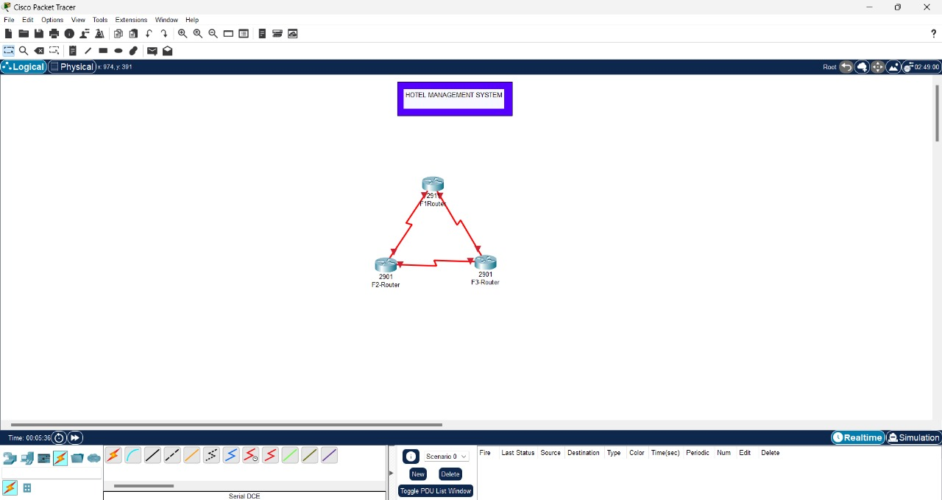

TOOK THREE 2960-2TT SWITCHES:

JOIN THE SWITCHES WITH THE ROUTERS:

NOW TOOK THE DEVICES FOR DIFFERENT FLOORS:

NOW CONNECT THE DEVICES WITH THE SWITCHES:

REPRESENTED THE DIFFERENT WITH DIFFERENT COLORS:

SEPARATED THE DEPARTMENTS AND LABELED ALSO:

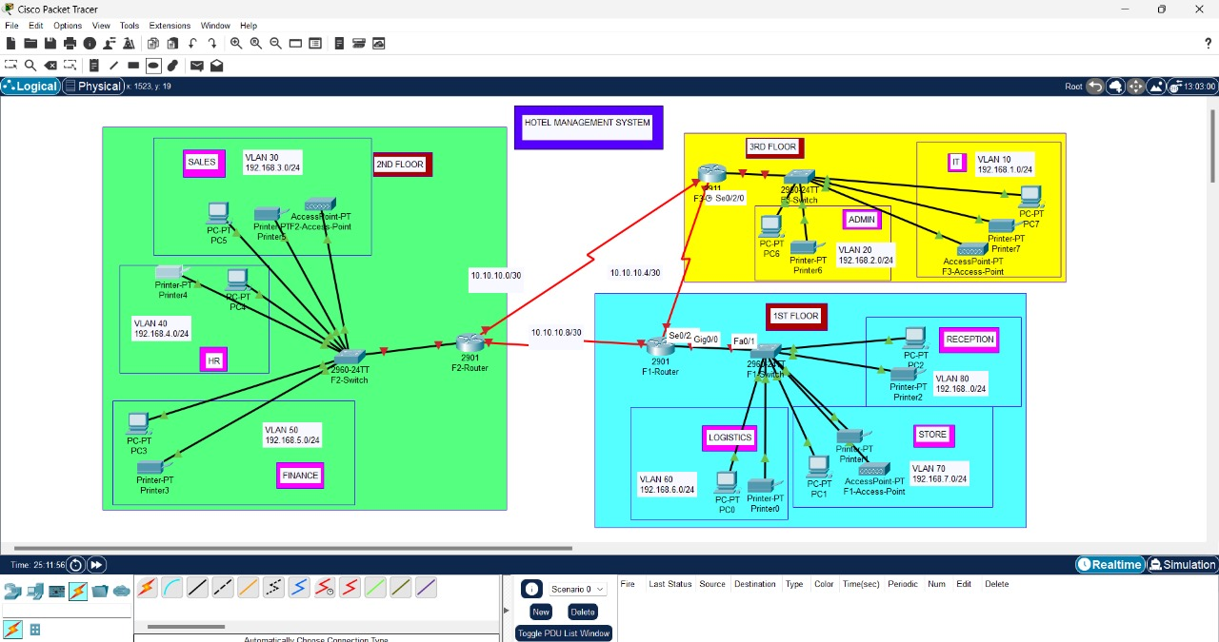

COMMANDS ARE ENTERED TO CONFIGURE THE ROUTERS INTERFACES:

FOR F3-ROUTER:

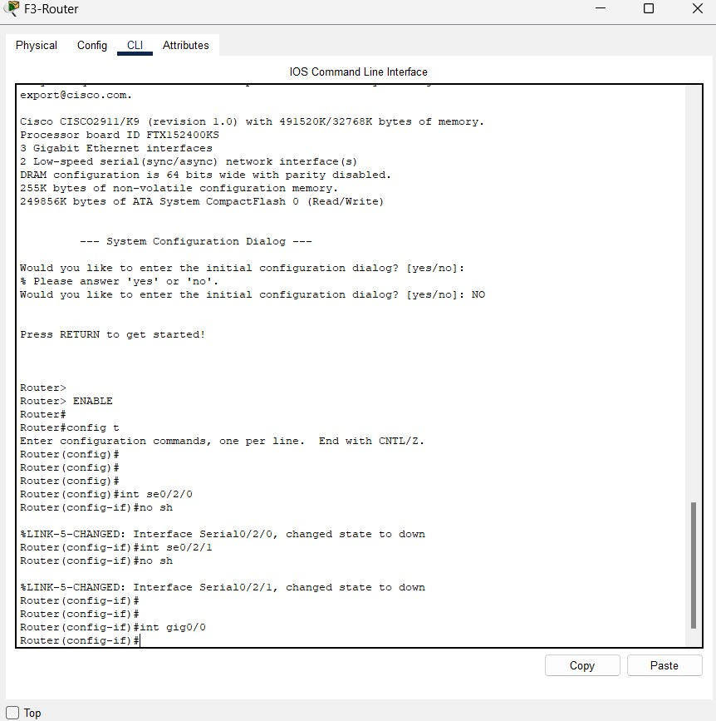

* **GigabitEthernet0/0**:
* Command: int gig0/0
* Brought online with: no shutdown
* Status changes to "up."
* **Serial Interface (Se0/2/0)**:
* Command: int se0/2/0
* Lists possible clock rates.
* 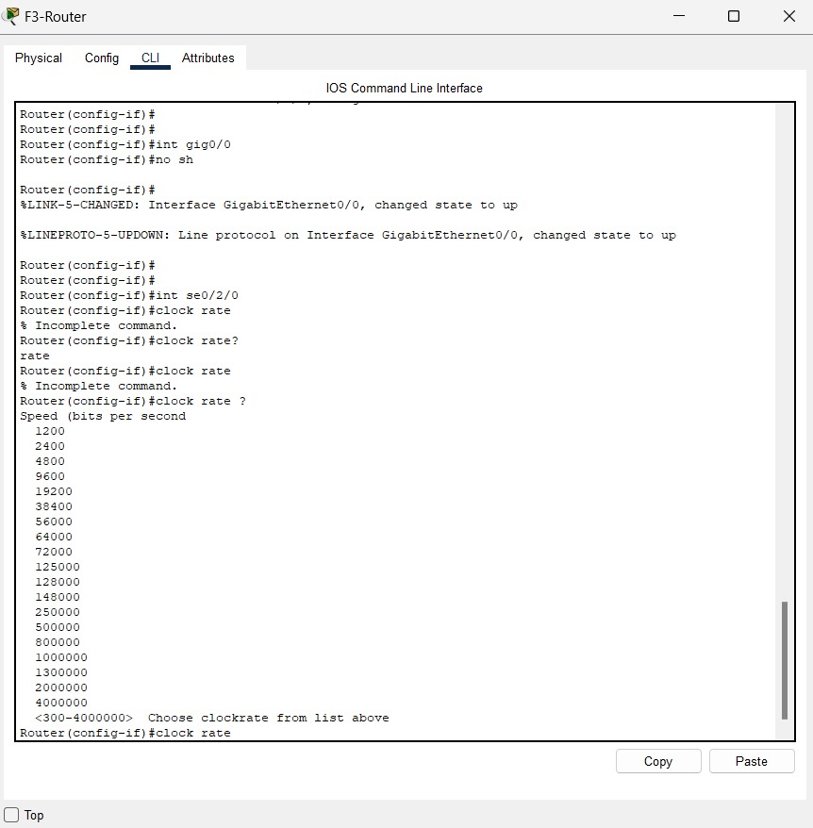

SAVE THE CURRENT CONFIGURATION WITH COMMAND DO WRITE:

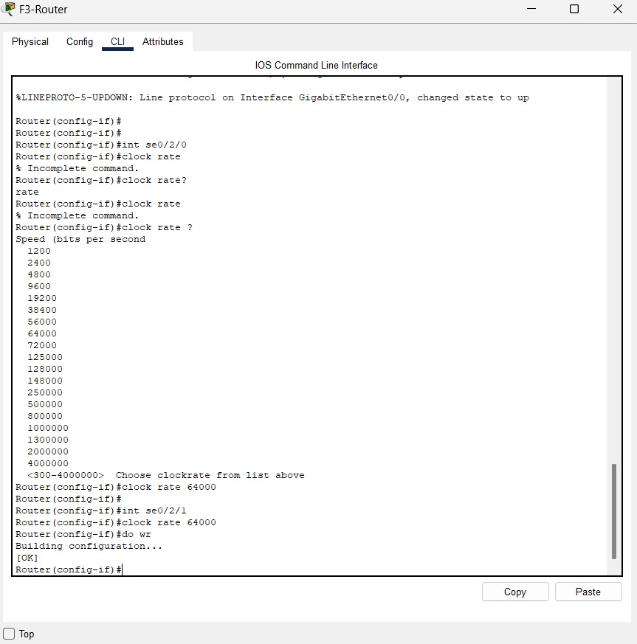

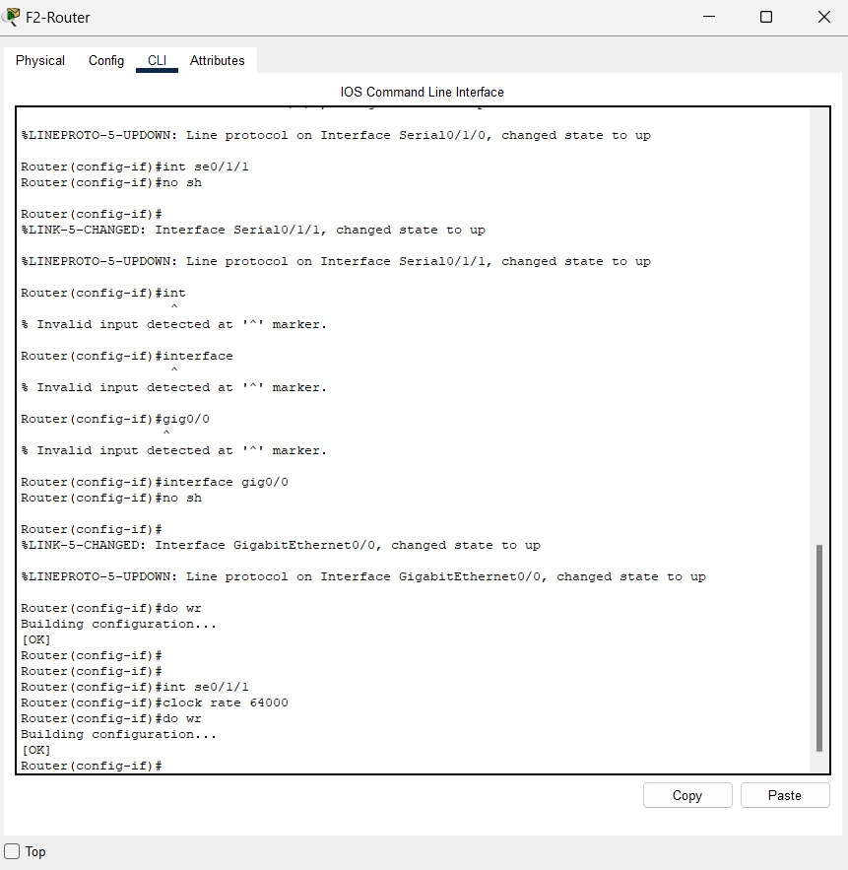FOR F2-ROUTER:

COMMANDS USED TO CONFIGURE SWITCHES:

* enable: Switches to privileged EXEC mode.
* config t: Enters global configuration mode.
* int range fa0/2-3: Selects Fast Ethernet interfaces 0/2 to 0/3.
* switchport mode access: Sets the selected interfaces to access mode.
* 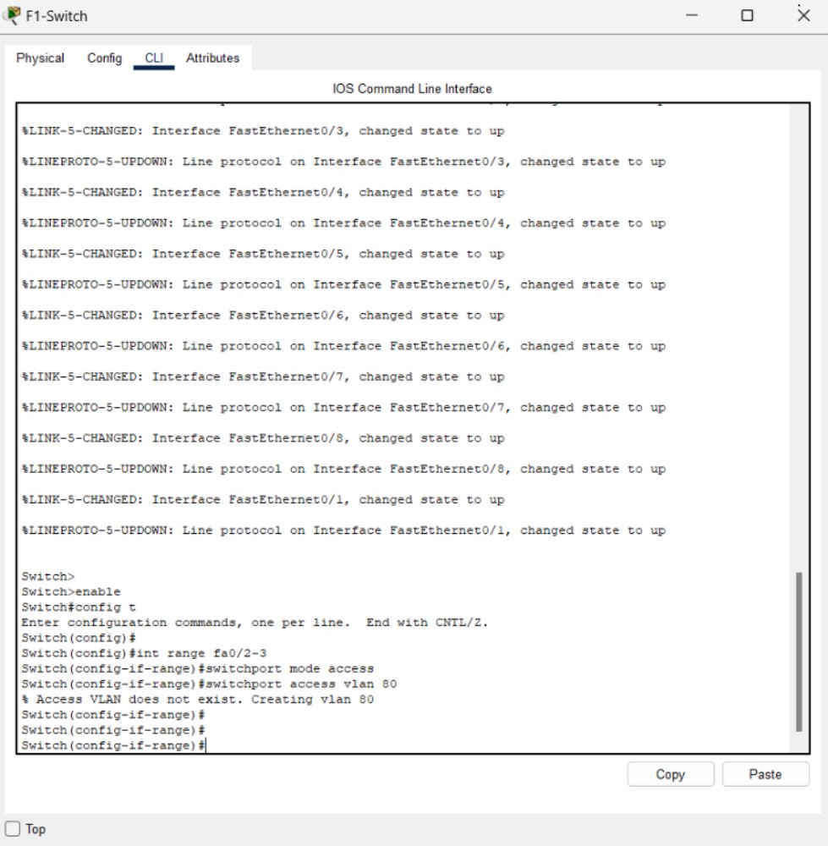switchport access VLAN 80: Assigns VLAN 80 to the interfaces

SWITCHPORT MODE ACCESS FOR VLAN70 AND VLAN 60:

SAVE CHANGES USING COMMAND DO WRITE:

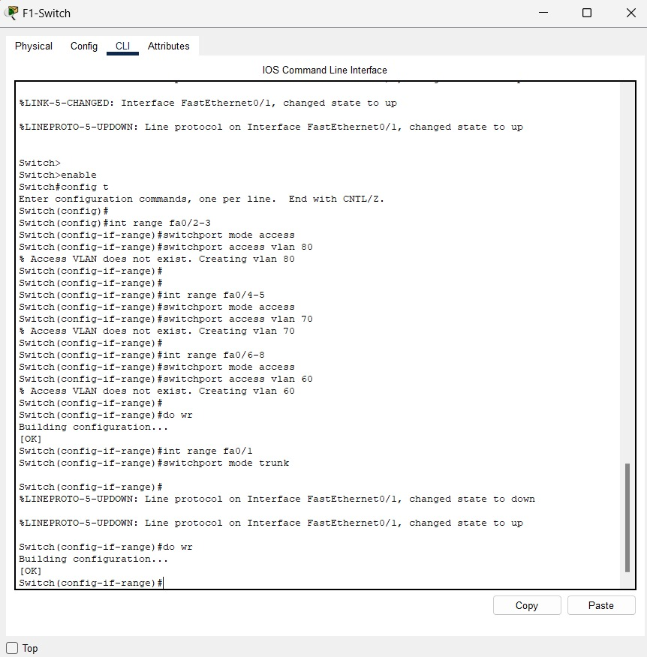ACTIVE TRUNK MODE NOW:

FOR F2-SWITCH NOW:

SWITCHPORT MODE ACCESS VLAN50 AND VLAN40:

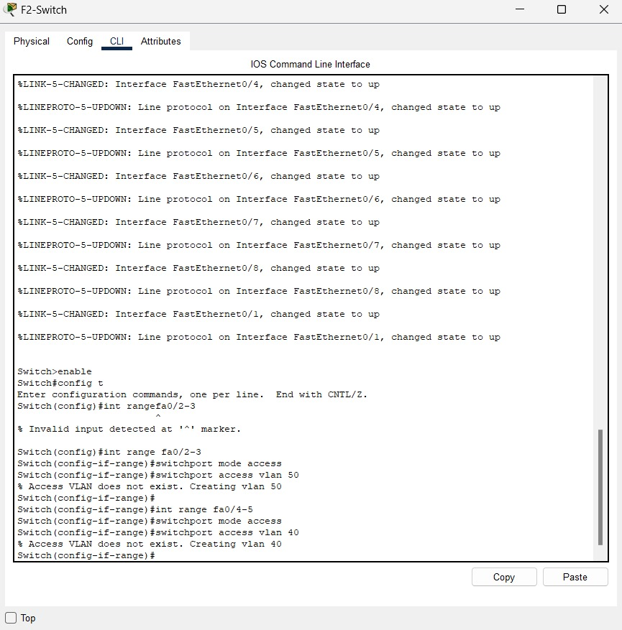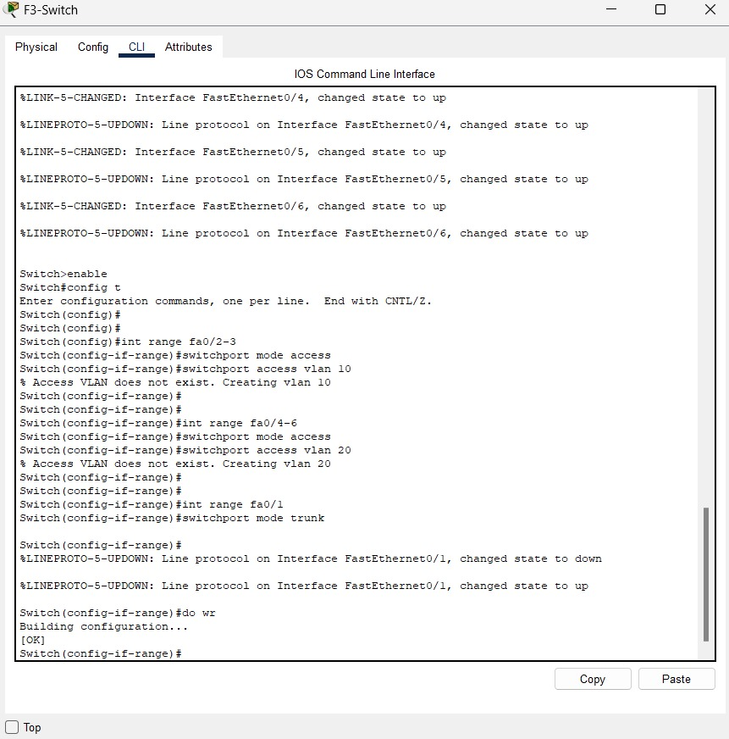

FOR F3-SWITCH AND TRUNK MODE ALSO ACTIVATED :

IP addresses are assigned to F1-ROUTER for specific interfaces:

1. se0/2/0:
   * Assigned IP address: 10.10.10.5
   * Subnet mask: 255.255.255.252
2. se0/2/1:
   * Assigned IP address: 10.10.10.9
   * Subnet mask: 255.255.255.252

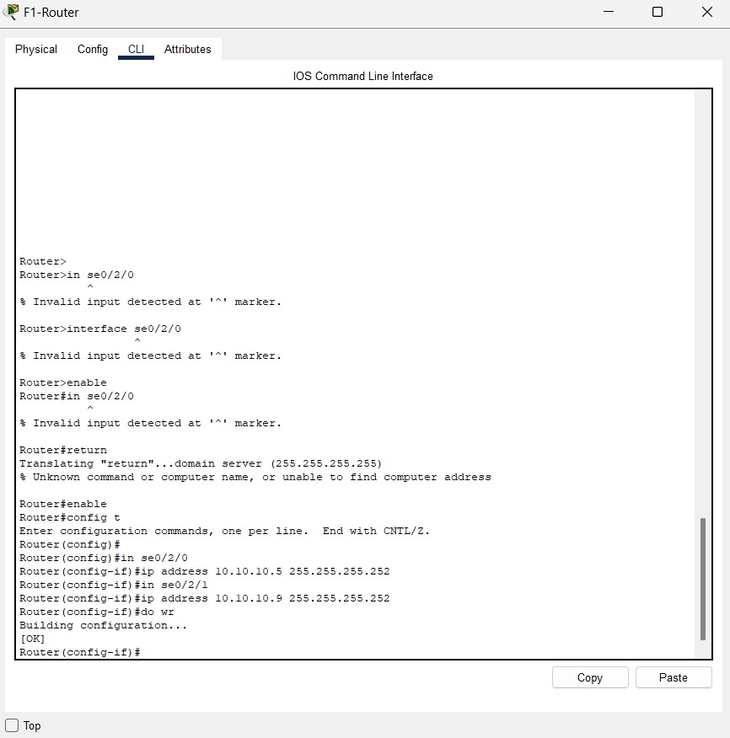

(CLI) session where IP addresses for F2-ROUTER are being assigned to two serial interfaces:

1. **Interface** se0/1/0:
   * Assigned IP address: 10.10.10.1
   * Subnet mask: 255.255.255.252
2. **Interface** se0/1/1:
   * Assigned IP address: 10.10.10.10
   * 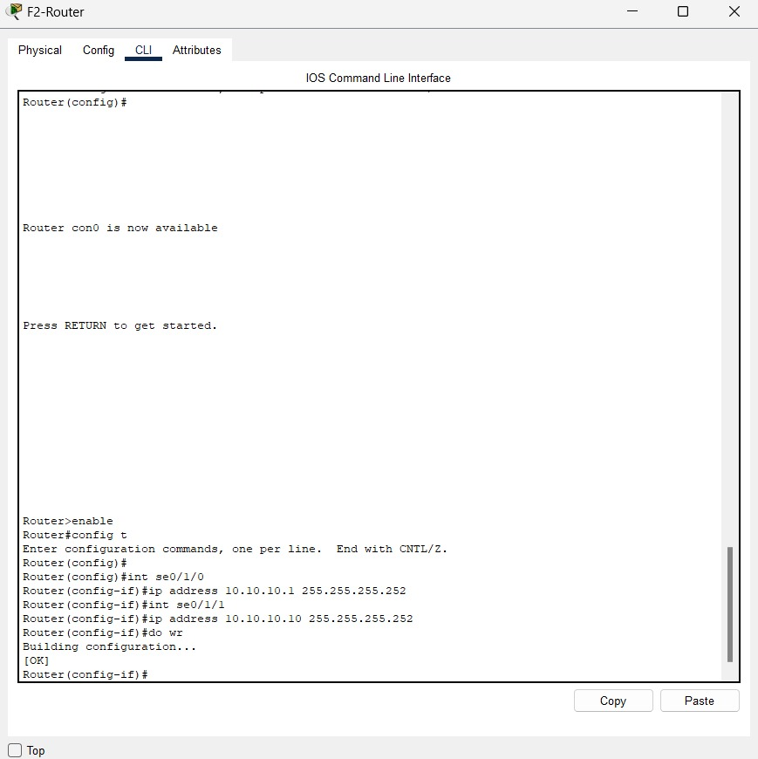Subnet mask: 255.255.255.252

**Enter Interface Mode**: The commands aim to configure the serial interfaces for F3-ROUTER:

1. **Assign IP Addresses**:

* se0/2/0: Assigned IP address 10.10.10.6 with subnet mask 255.255.255.252.
* se0/2/1: Assigned IP address 10.10.10.2 with subnet mask 255.255.255.252.

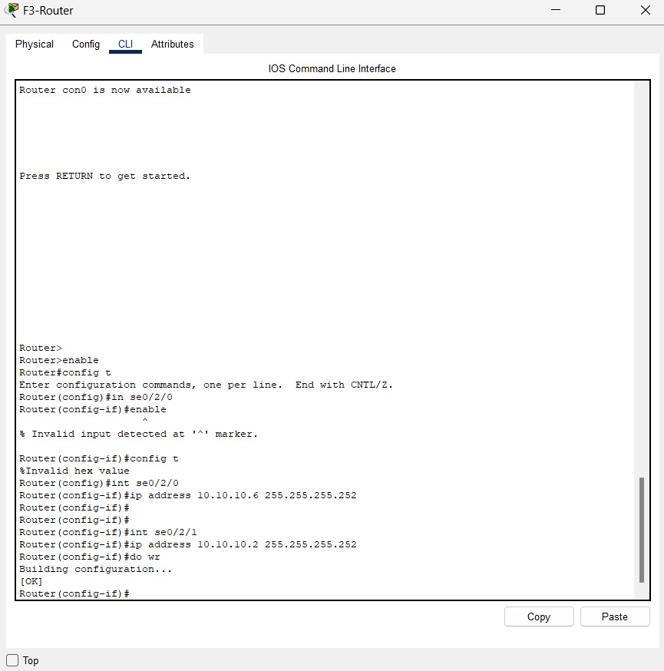**2.Save Configuration**: The do write command saves the current configuration.

CONFIGURING SUB-INTERFACES ON F1-ROUTER:

1. **GigabitEthernet0/0.80**:
   * VLAN 80
   * IP: 192.168.8.1/24
2. **GigabitEthernet0/0.70**:
   * VLAN 70
   * IP: 192.168.7.1/24
3. **GigabitEthernet0/0.60**:
   * VLAN 60
   * IP: 192.168.6.1/24
4. **Save Configuration**: do write saves the changes.

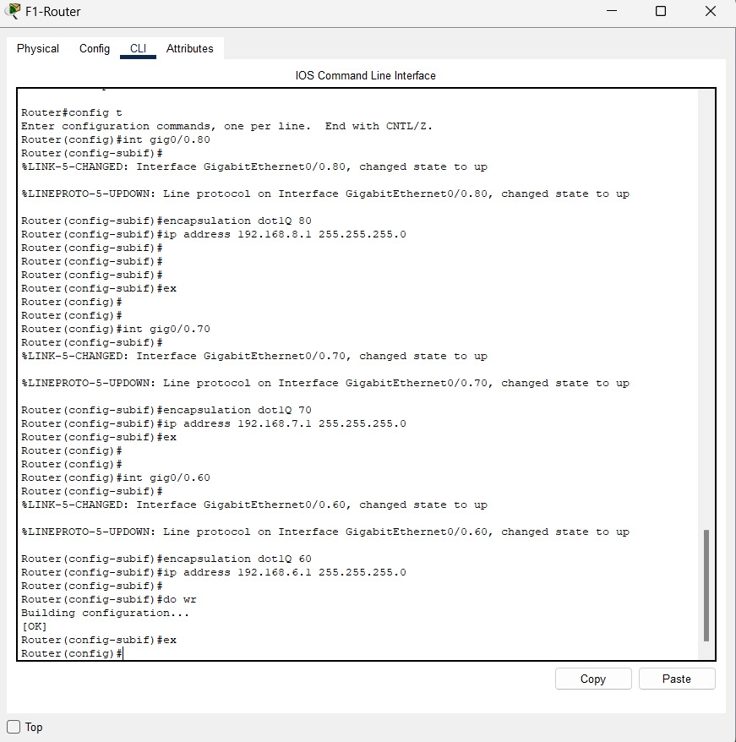

DHCP POOLS ON F1-ROUTER:

1. **Configure Sub-Interface**:
   * GigabitEthernet0/0.60 with IP 192.168.6.1/24.
2. **Enable DHCP Service**:
   * Configures DHCP pools for different departments:
     + **RECEPTION**: Network 192.168.8.0/24, Router 192.168.8.1, DNS 192.168.8.1.
     + **STORE**: Network 192.168.7.0/24, Router 192.168.7.1, DNS 192.168.7.1.
     + **LOGISTICS**: Network 192.168.6.0/24, Router 192.168.6.1, DNS 192.168.6.1.
3. **Save Configuration**:
   * 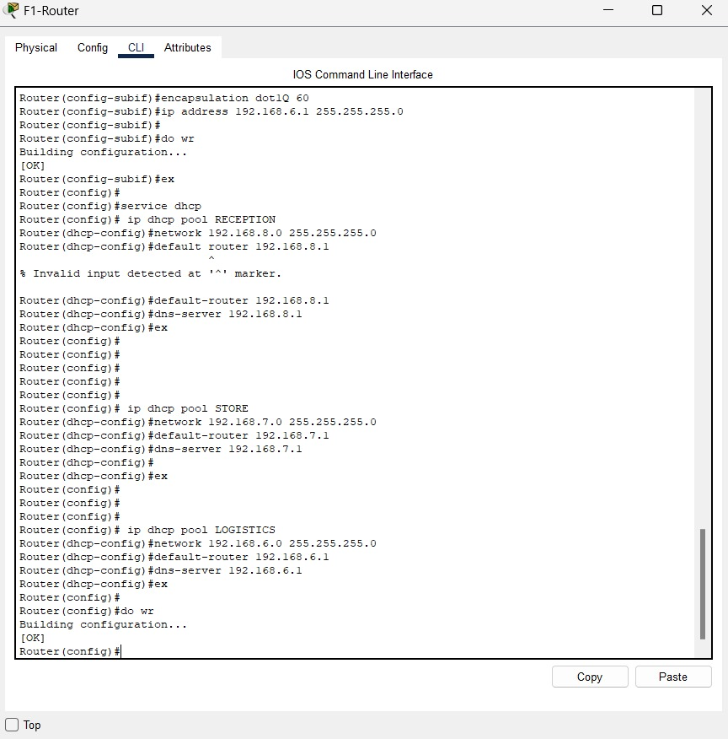Executes do write again to save the changes.

DHCP REQUESTING IP FOR PC 2:

DHCP REUQUESTING PC0 FOR CHECKING CORRECT IPs OF ROUTERS:

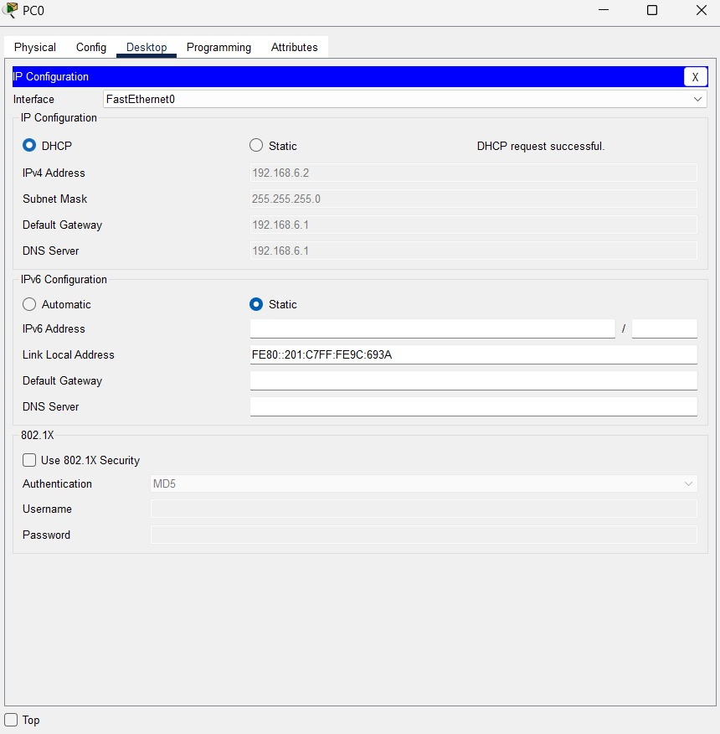

CONFIGURATION OF SUB-INTERFACES ON F2- ROUTER:

1. **Sub-interface Gig0/0.30**:
   * VLAN 30 (dot1Q 30)
   * IP: 192.168.3.1/24
2. **Sub-interface Gig0/0.40**:
   * VLAN 40 (dot1Q 40)
   * IP: 192.168.4.1/24
3. **Sub-interface Gig0/0.50**:
   * VLAN 50 (dot1Q 50)
   * IP: 192.168.5.1/24
4. **Save Configuration**: The do write command saves the changes.

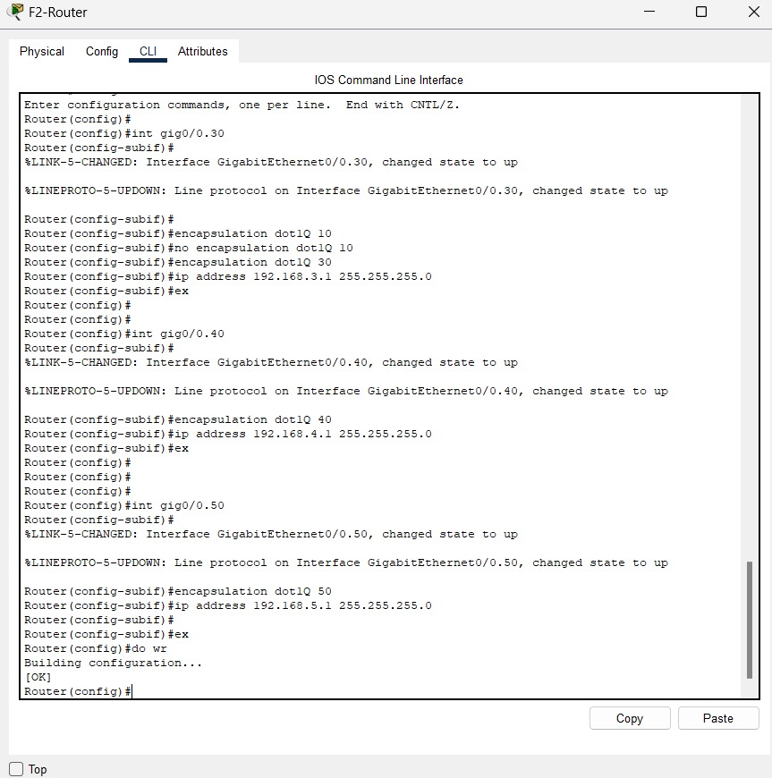

DHCP POOLS ON F2-ROUTER:

1. **Sub-interface Gig0/0.50**:
   * VLAN 50 (dot1Q 50)
   * IP: 192.168.5.1/24
2. **DHCP Pools**:
   * **FINANCE**: Network 192.168.5.0/24, Router 192.168.5.1, DNS 192.168.5.1
   * **HR**: Network 192.168.4.0/24, Router 192.168.4.1, DNS 192.168.4.1
3. 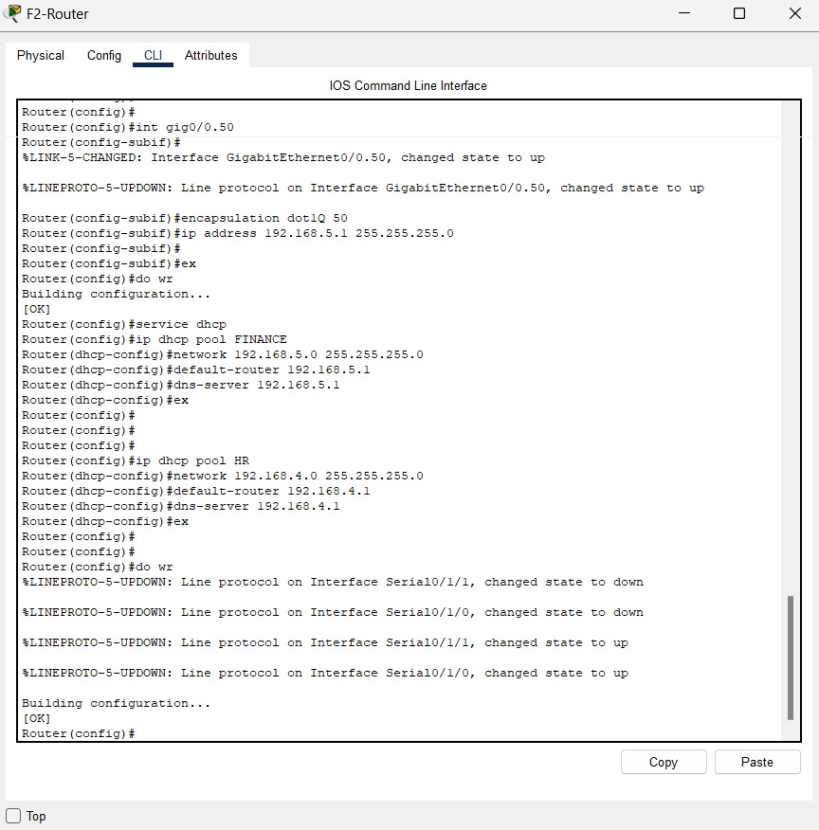**Save Configuration**: do write to save changes.

DHCP REQUESTING IP FOR PC5 FOR PING TEST:

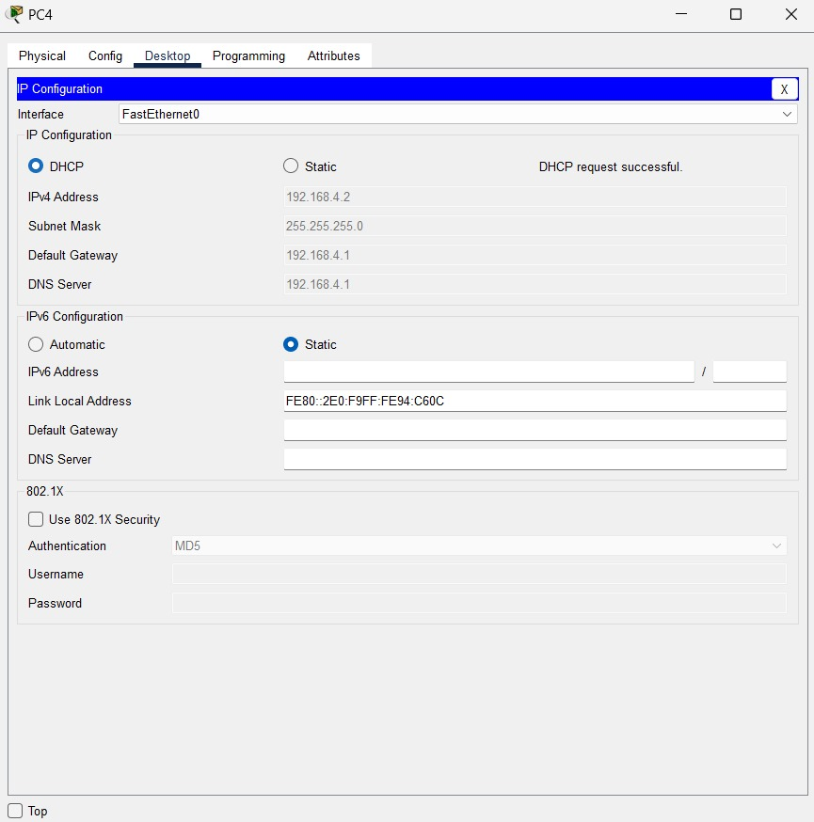DHCP REQUESTING IP FOR PC4:

PINGING FROM PC3 TO PC5:

CONFIGURING SUB-INTERFACES AND DHCP POOLS ON F3-ROUTER:

1. **Sub-interface Configuration**:
   * GigabitEthernet0/0.10:
     + Encapsulation: dot1Q 10
     + IP Address: 192.168.1.1/24
   * GigabitEthernet0/0.20:
     + Encapsulation: dot1Q 20
     + IP Address: 192.168.2.1/24
2. **DHCP Pools Configuration**:
   * **Pool IT**:
     + Network: 192.168.1.0/24
     + Default Router: 192.168.1.1
     + DNS Server: 192.168.1.1
   * **Pool ADMIN**:
     + Network: 192.168.2.0/24
     + Default Router: 192.168.2.1
     + DNS Server: 192.168.2.1
3. **Save Configuration**:
   * do write saves the changes.

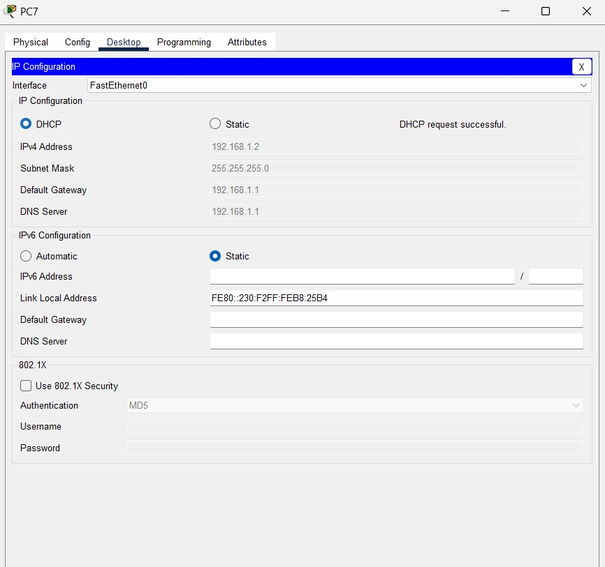 DHCP REQUESTING IP FOR PC7:

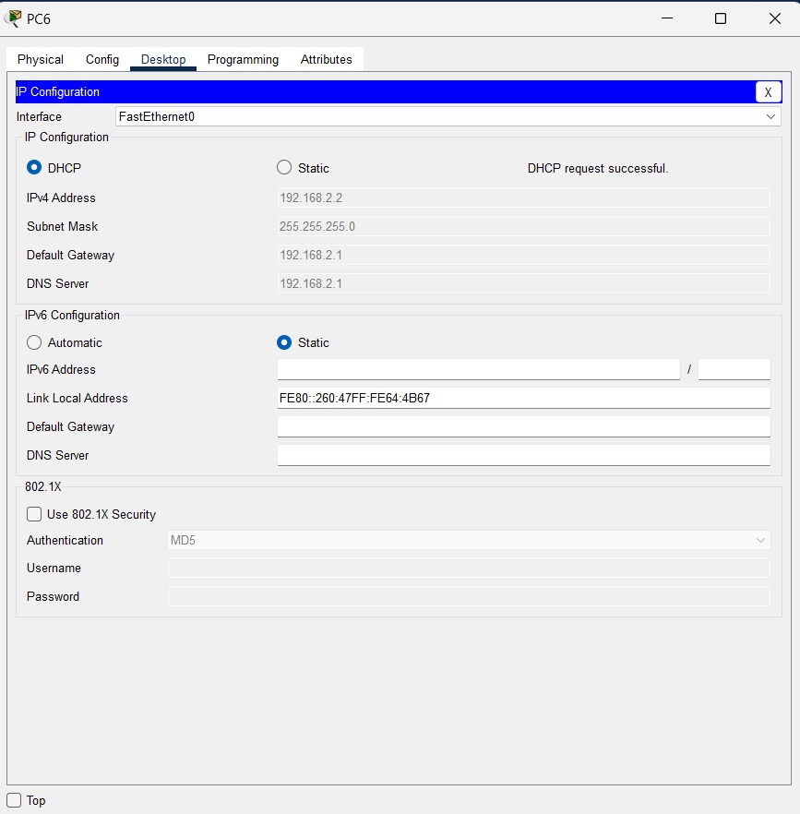DHCP REQUESTING IP FOR PC6:

PINGING FROM PC6 TO PC7:

**OSPF F1-Router Configuration**:

* **Enter OSPF mode**: router OSPF 10
* **Add Networks to OSPF**:
  + 10.10.10.4/30 in area 0
  + 10.10.10.8/30 in area 0
  + 10.10.10.7/30 in area 0
  + 192.168.8.0/24 in area 0
  + 192.168.7.0/24 in area 0
  + 192.168.6.0/24 in area 0

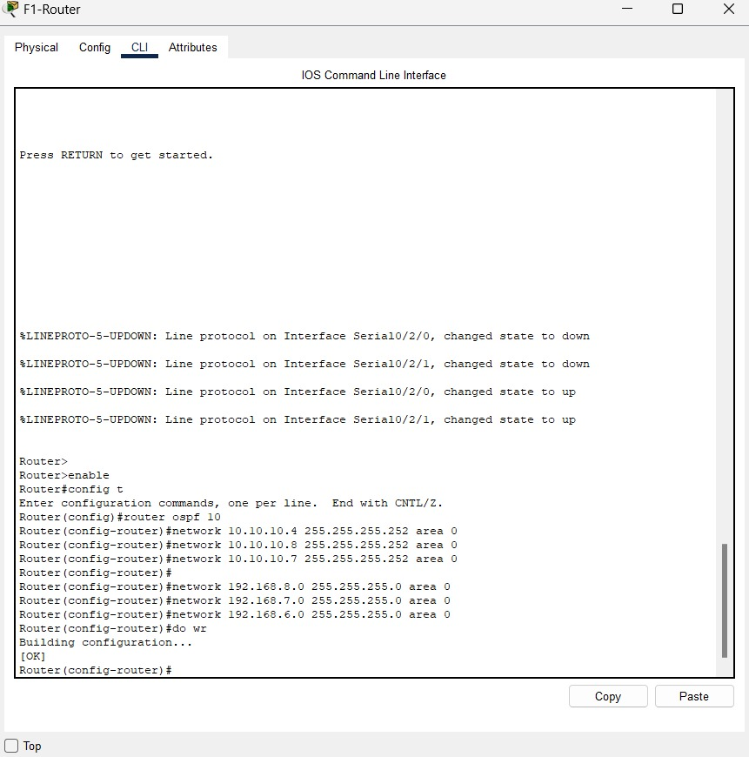 **Save Configuration**: do write saves the settings.

CONFIGURING OSPF FOR F2-ROUTER:

1. **Enter OSPF Mode**:
   * Command: router OSPF 10
2. **Add Networks to OSPF**:
   * 10.10.10.0/30 in area 0
   * 10.10.10.4/30 in area 0
   * 10.10.10.8/30 in area 0
   * 192.168.4.0/30 in area 0
   * 192.168.5.0/30 in area 0
3. **Save Configuration**:
   * 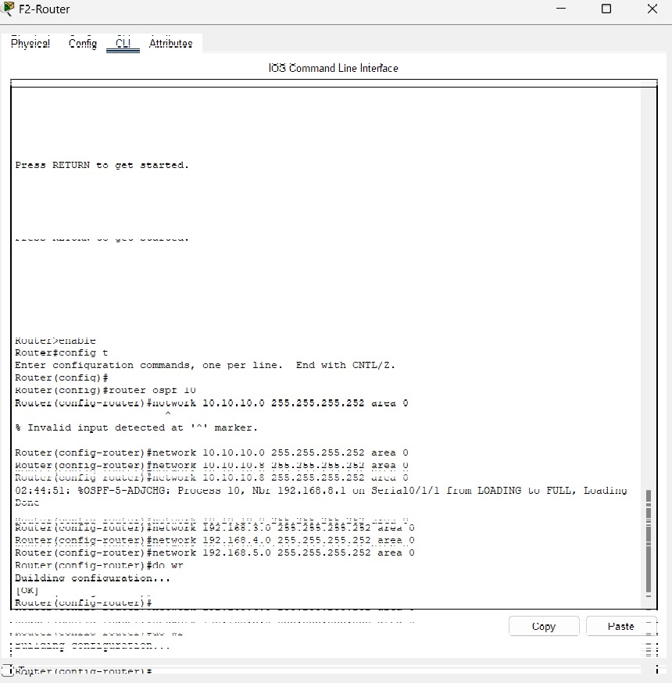write to save the settings.

CONFIGURING OSPF FOR F3-ROUTER:

E**nter OSPF Mode**:

* Command: router OSPF 10

**Add Networks to OSPF**:

* 10.10.10.0/24 in area 0
* 192.168.1.0/24 in area 0
* 192.168.2.0/24 in area 0

**Save Configuration**:

* 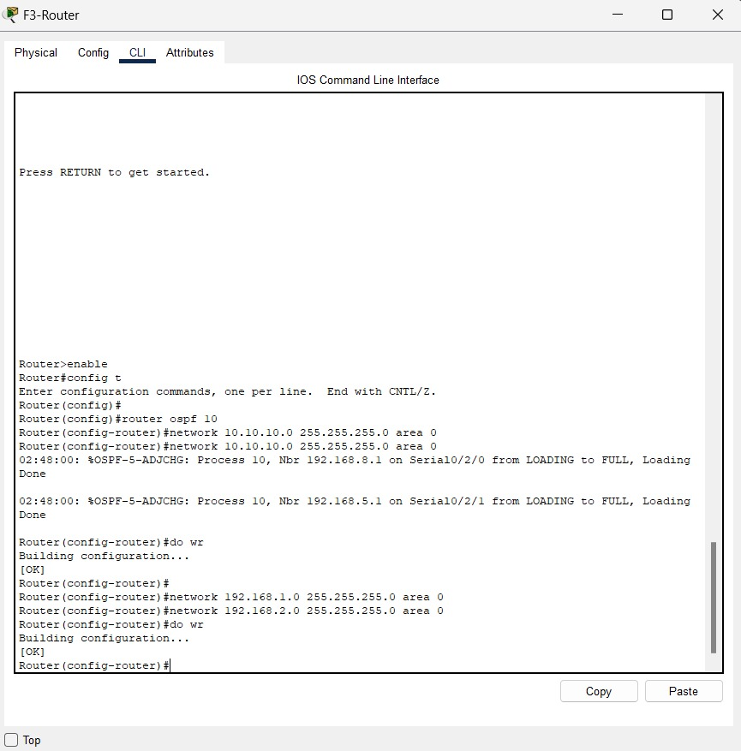do write to save changes.

PINGING FROM PC6 TO PC0:

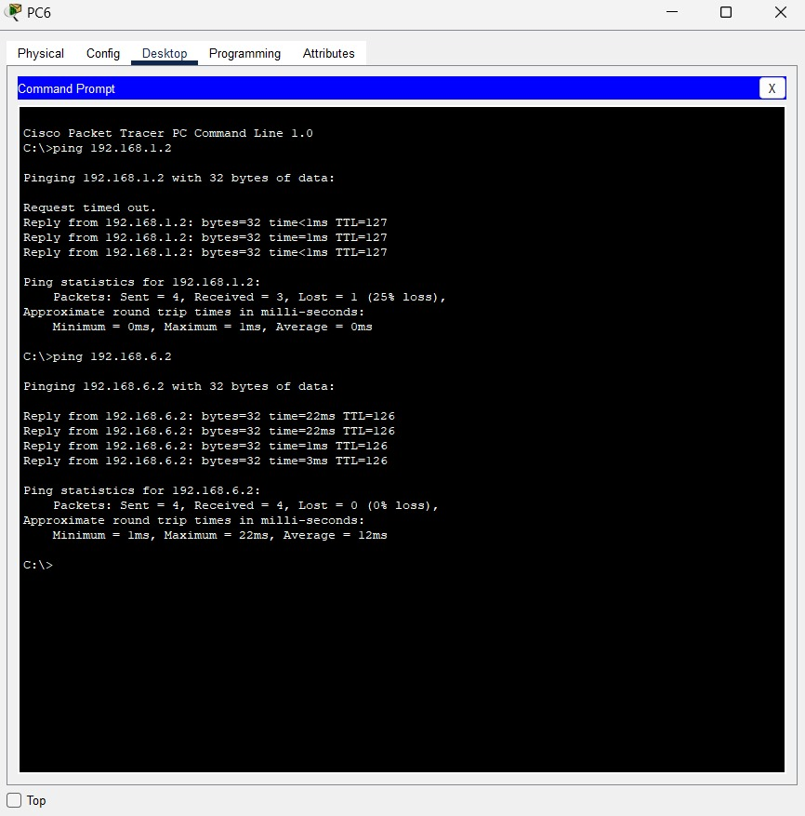

PINGING FROM PC6 TO PRINTER 5:

SET PASSWORD AT 2ND FLOOR ACCESS POINT:

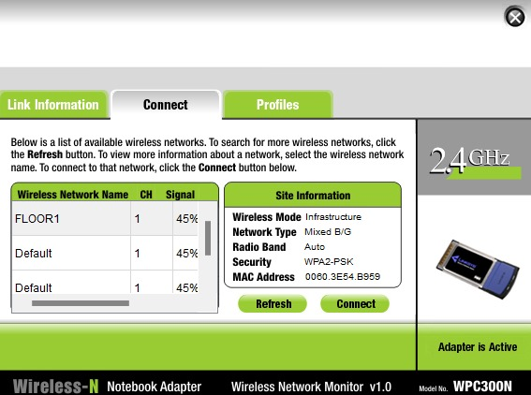

CONNECTING LAPTOP WITH SECOND FLOOR WIFI:

CONNECT SMARTPHONE 0 WITH 2ND FLOOR WIFI:

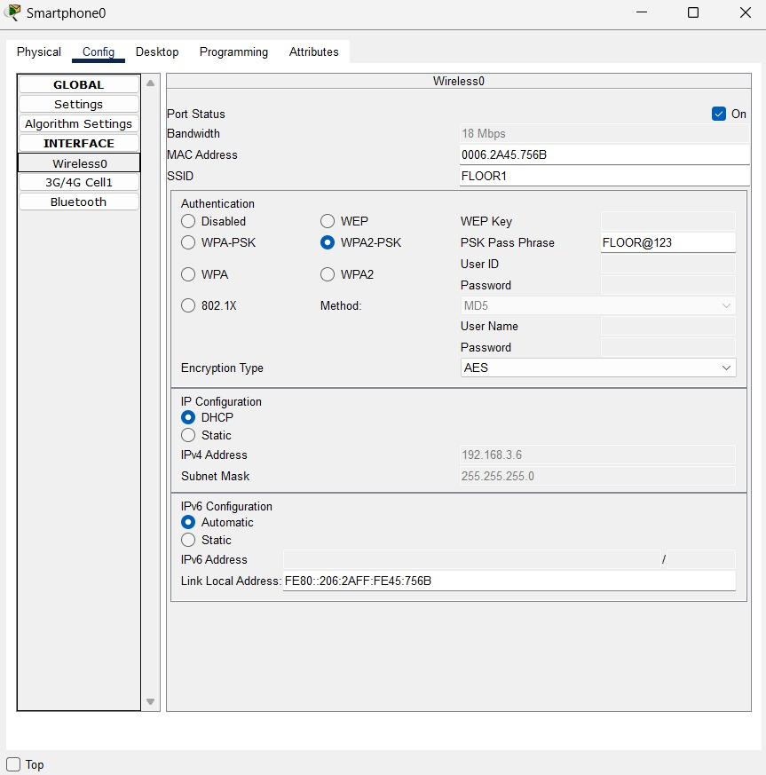

CONNECT PCO TABLET WITH SECOND FLOOR WIFI:

PASSWORD: FLOOR@123

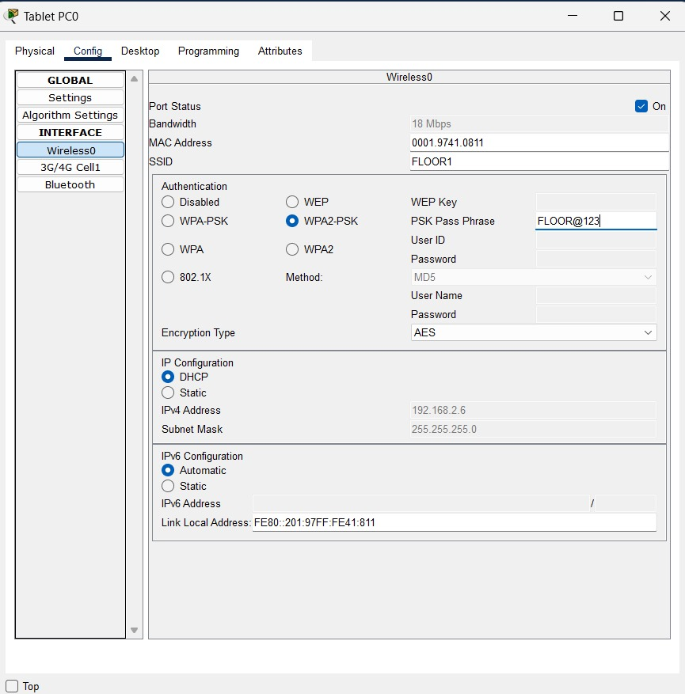

2ND FLOOR ACCESS POINT WIFI CONNECTED WITH ALL THREE DEVICES SUCCESSFULLY:

1ST FLOOR ACCESS POINT WIFI CONNECTED WITH ALL THREE DEVICES SUCCESSFULLY:

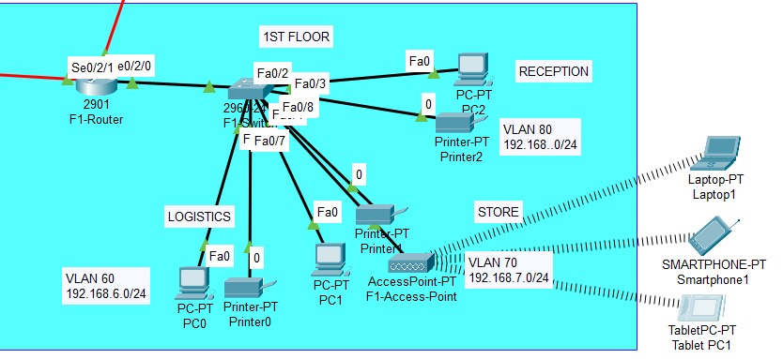

CONFIGURATION OF "F3-Router" TO ENABLE SSH FOR SECURE REMOTE ACCESS.

1. **Hostname and Domain Name Configuration**:
   * Set hostname to F3-Router.
   * Set domain name to gtech.
2. **User Configuration**:
   * Create a user gtech with the password gtech.
3. **Generate RSA Keys for SSH**:
   * Command: crypto key generate rsa
   * Key size: 1024 bits.
4. **Enable SSH**:
   * SSH version 1.99 is enabled.
5. **Configure VTY Lines for SSH Access**:
   * Specify virtual terminal (vty) lines 0 to 15.
   * Set login method to local.
   * Allow only SSH for remote access.
6. **Save Configuration**:
   * 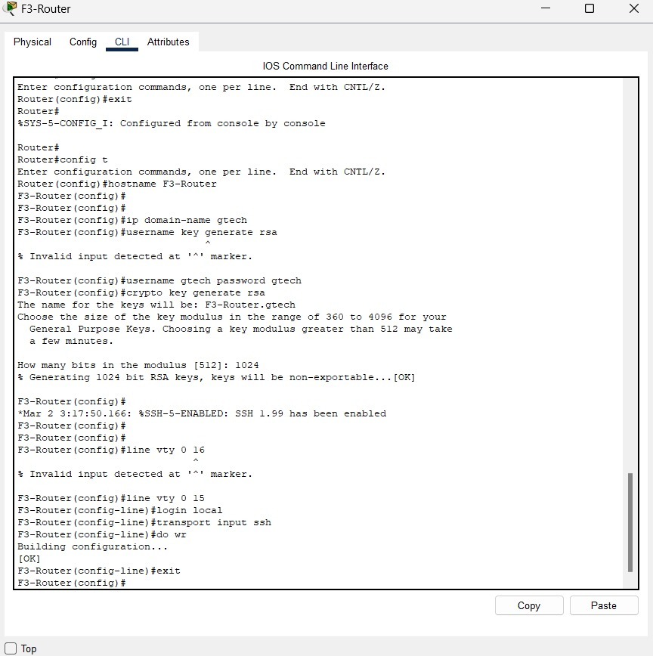Command: do write to save the configuration.

CONFIGURING F2-ROUTER FOR SSH:

1. **Set Hostname**:
   * hostname F2-Router
2. **Set Domain Name**:
   * ip domain-name gtech
3. **Create User**:
   * username gtech password gtech
4. **Generate RSA Keys**:
   * crypto key generate RSA
   * Key size: 1024 bits
5. **Enable SSH**:
   * line vty 0 15
   * login local
   * transport input ssh
6. **Save Configuration**:
   * do write

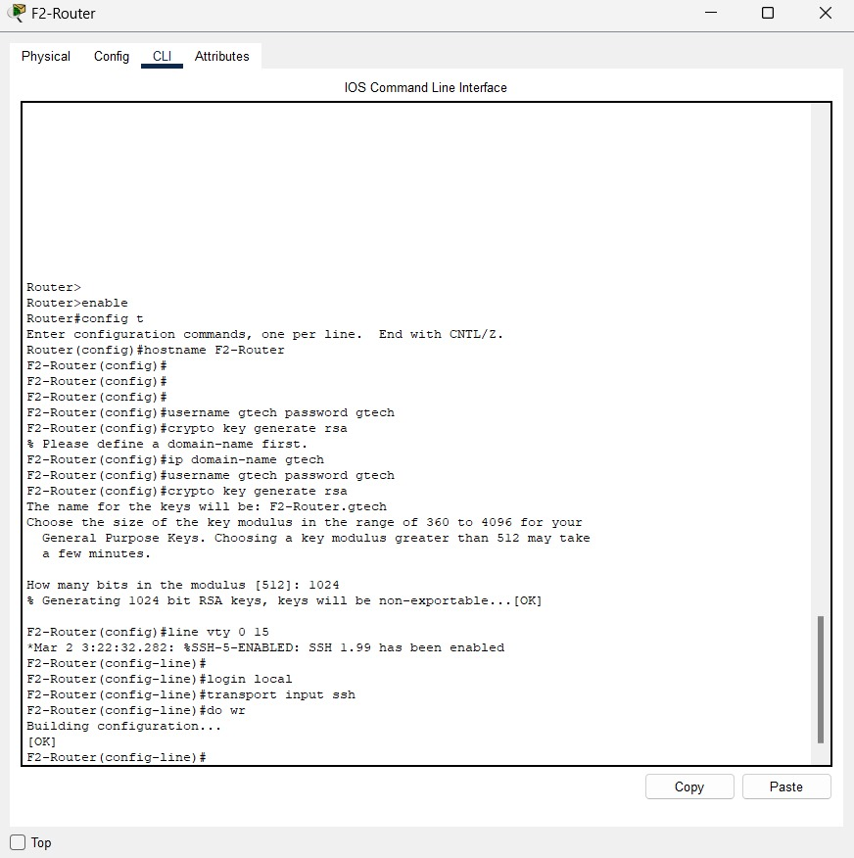

CONFIGURATION "FI-Router" TO ENABLE SSH ACCESS FOR SECURE REMOTE MANAGEMENT.

1. **Set Hostname**:
   * hostname FI-Router
2. **Set Domain Name**:
   * ip domain-name gtech
3. **Create User**:
   * username gtech password gtech
4. **Generate RSA Keys**:
   * Command: crypto key generate rsa
   * Key size: 1024 bits
5. **Enable SSH**:
   * SSH version 1.99 enabled
6. **Configure VTY Lines for SSH Access**:
   * line vty 0 15
   * login local
   * transport input ssh
7. **Save Configuration**:
   * 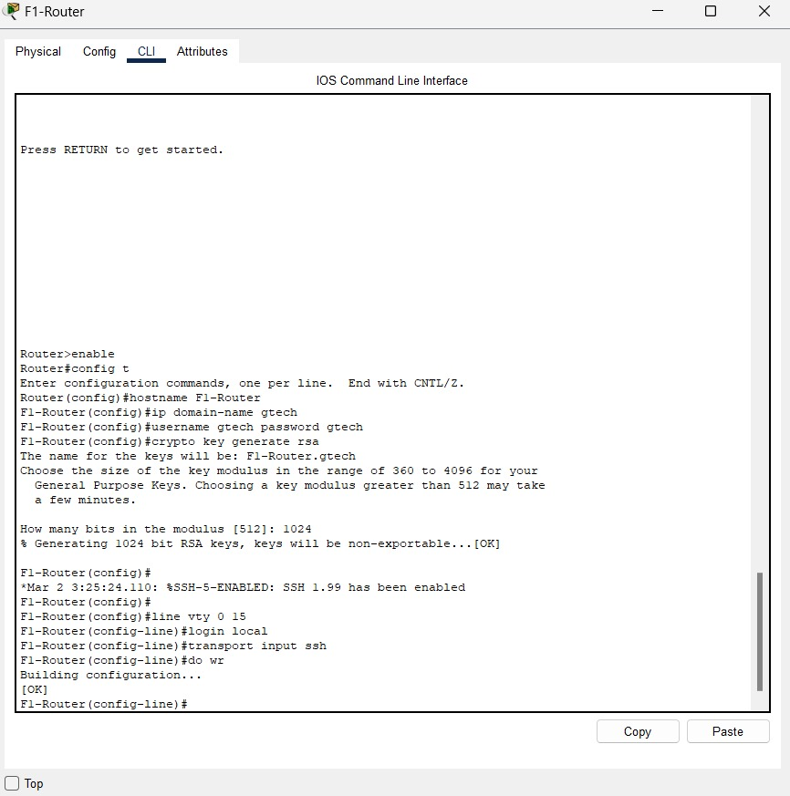Command: do write

SSH TEST BY TEST PC TO ROUTER1:

PASSWORD: gtech(invisible)

CONFIGURING PORT SECURITY ON F3-SWITCH.

1. **Access Interface**:
   * Command: int fa0/2
2. **Enable Port Security**:
   * Command: switchport port-security
3. **Set Maximum MAC Addresses**:
   * Command: switchport port-security maximum 1
4. **Enable Sticky MAC Address**:
   * Command: switchport port-security mac-address sticky
5. **Set Violation Mode to Shutdown**:
   * Commands:
     + switchport port-security violation ?
     + switchport port-security violation shutdown
6. **Save Configuration**:
   * Command: do write

CONFIGURATION OF NETWORK F3-SWITCH:

1. **Switch Hostname**:
   * Switch
2. **Spanning Tree Protocol (STP)**:
   * Mode: PVST (Per-VLAN Spanning Tree)
   * Extend system-id
3. **Interface Configurations**:
   * FastEthernet0/1: Trunk mode.
   * FastEthernet0/2: Access mode, VLAN 10, port-security with sticky MAC addresses.
   * FastEthernet0/3: Access mode, VLAN 10.
   * FastEthernet0/4 to FastEthernet0/6: Access mode, VLAN 20.
   * FastEthernet0/7 and FastEthernet0/8: Access mode.
4. **Save Configuration**:
   * The do write command saves the settings.

CONFIGURING AND VERIFYING PORT SECURITY ON A NETWORK

F3-SWITCH:

1. **Interface Configuration**:
   * Configures multiple FastEthernet interfaces (Fa0/6 to Fa0/11), setting them to access mode and assigning VLANs.
2. **Error and Correction**:
   * There's an error with the command exit, corrected to exit.
3. **Port Security Command**:
   * The shutdown port-security command initially fails but succeeds with do shutdown port-security.
4. **Port Security Status**:
   * **Fa0/2**:
     + Max Secure Addresses: 1
     + Current Addresses: 0
     + Security Violations: 0
     + Security Action: Shutdown

